# EO Requests Tool — System Architecture

**Stack:** ASP.NET Core (.NET 8 LTS), Blazor Server + MVC (hybrid), SQL Server 2019+, EF Core, SignalR, Hangfire, OpenIddict (SSO), Serilog, SMTP, IIS on Windows Server 2022

**Environments:** DEV → UAT → PROD (IIS sites per env, separate SQL DBs, feature flags via appsettings)

――――――――――――――――――――――――――――――――――――――――

## 1) High-Level Overview

* \*\***Presentation Layer**\*\*: Blazor Server UI (interactive forms, wizards), MVC endpoints for APIs and admin screens.
* \*\***Application Layer**\*\*: Request Orchestrator, Workflow Engine, Task Service, Notification Service, Attachment Service, SLA/Escalation Service, Access Control Service.
* \*\***Domain Layer**\*\*: Entities (Request, Workflow, Step, Task, Attachment…), Value Objects, Domain Events.
* \*\***Infrastructure Layer**\*\*: EF Core DbContexts, Repositories, OpenIddict (SSO/RBAC), Hangfire (jobs), SignalR (real-time), Serilog (logging), SMTP (email), File Storage.

――――――――――――――――――――――――――――――――――――――――

## 2) Component Diagram

flowchart TB  
 subgraph Client[EO Staff & Reviewers]  
 B(Desktop Browser)  
 end  
  
 B -->|HTTPS/SSO| W[IIS + ASP.NET Core (Blazor Server + MVC)]  
  
 subgraph App[Application Layer]  
 RO[Request Orchestrator]  
 WF[Workflow Engine]  
 TS[Task Service]  
 CS[Comment & Collaboration Service]  
 NS[Notification Service]  
 AS[Attachment Service]  
 AC[Access Control Service]  
 SLA[SLA/Escalation Service]  
 end  
  
 W --> RO  
 RO --> WF  
 RO --> TS  
 RO --> AS  
 RO --> AC  
 RO --> CS  
 WF --> SLA  
 WF --> AC  
 TS --> NS  
 CS --> NS  
 RO --> NS  
  
 subgraph Infra[Infrastructure]  
 DB[(SQL Server)]  
 HG[Hangfire Jobs]  
 SG[SignalR Hub]  
 SSO[OpenIddict (AuthN/AuthZ)]  
 SMTP[SMTP Relay]  
 FS[(File Storage)]  
 LG[Serilog Sinks]  
 end  
  
 W <-->|Auth| SSO  
 W <-->|Real-time| SG  
 App <--> DB  
 AS <--> FS  
 NS --> SMTP  
 SLA --> HG  
 W --> LG

――――――――――――――――――――――――――――――――――――――――

## 3) Key Modules & Responsibilities

### 3.1 Presentation Layer

* \*\***Blazor Server UI**\*\*: Dynamic form wizard (JSON-schema driven), conditional fields, role/user-based visibility, inline task panel, step comments (chat), threaded discussions with reply levels (2–3 levels max for clarity), @mention tagging with notifications, activity timeline, dashboards.
* \*\***MVC**\*\*: REST-style endpoints for admin config, file streaming (inline preview), webhook-style callbacks.

### 3.2 Application Layer

* \*\***Request Orchestrator**\*\*
* Creates request instances from templates; binds selected workflow; handles submit/recall/close.
* \*\***Workflow Engine**\*\*
* Executes step rules, branching/skip conditions, and transitions.
* Assignment modes: `RoleBased`, `SelectedByPreviousStep` (person pick), `AutoAssign` (creator/last submitter).
* Maintains `WorkflowState` and emits domain events.
* \*\***Task Service**\*\*
* Step tasks/subtasks, dependencies (gating), progress status, reminders; observers.
* \*\***Comment & Collaboration Service**\*\*
* Threaded comments per entity (Request, WorkflowState/Step, TaskItem).
* **\*\*@mentions**\*\* with user picker; writes `Mention` records and triggers notifications.
* \*\***Visibility modes**\*\*: `Internal` (staff-only) vs `RequesterVisible` (submitter + authorized roles).
* \*\***Threading**\*\*: 2–3 levels (reply-to-comment) with collapse/expand; prevent infinite depth.
* \*\***Reactions**\*\* (👍, ✅) optional for lightweight acks; stored as `CommentReaction`.
* \*\***Edit/Delete policy**\*\*: short edit window (e.g., 10–15 min), deletions are soft with audit.
* \*\***Moderation**\*\*: role-based delete/hide; anti-spam throttle.
* \*\***Notification Service**\*\*
* In-app via SignalR, email via SMTP; templates via Razor; user preferences.
* \*\***Attachment Service**\*\*
* Drag/drop uploads, metadata, versioning, inline viewer, soft delete + purge (Hangfire).
* \*\***SLA/Escalation Service**\*\*
* Due date calc, reminders, escalation chains; job scheduling (Hangfire).
* \*\***Access Control Service**\*\*
* Evaluates permissions per action: by role, by specific assignee, or by creator/preparer flags.

### 3.3 Domain Layer (Core Entities)

* `Request` / `RequestType`
* `WorkflowTemplate`, `WorkflowStepTemplate`, `WorkflowInstance`, `WorkflowState`
* `TaskItem`, `TaskReminder`
* `CommentThread`, `Comment`, `CommentReaction`, `Mention`, `CommentVisibility`
* `Attachment` (+ version group), `EntityObserver`, `EntityRelation`
* `SlaRule`, `EscalationRule`
* `Notification`, `ActivityLog`
* Enums: `EntityType`, `WorkflowStateCode`, `TaskProgressStatus`, `AssignmentMode`, `CommentVisibility`

### 3.4 Infrastructure

* \*\***Auth**\*\*: OpenIddict; role claims + user-specific step permissions.
* \*\***Data**\*\*: EF Core DbContext, migrations, read-optimized views for dashboards.
* \*\***Real-time**\*\*: SignalR hubs for notifications and live step/task updates.
* \*\***Jobs**\*\*: Hangfire dashboard (role-restricted), scheduled reminders, purge, sync jobs.
* \*\***Logging/Monitoring**\*\*: Serilog (file/SQL/Seq), health checks, App Insights (optional).
* \*\***Storage**\*\*: File system or UNC share (with anti-virus scan hook), size/type validation.

――――――――――――――――――――――――――――――――――――――――

## 4) Data Model (High-Level)

classDiagram  
 class Request { Guid Id; Guid RequestTypeId; Guid CreatedByUserId; DateTime CreatedOn; Status Status }  
 class WorkflowTemplate { Guid Id; string Code; string Name }  
 class WorkflowStepTemplate { Guid Id; int Order; string Code; string AssignmentMode; string AllowedRolesCsv; bool AllowCreatorOrPreparer }  
 class WorkflowInstance { Guid Id; Guid RequestId; Guid CurrentStepId; bool IsComplete }  
 class WorkflowState { Guid Id; Guid InstanceId; Guid CurrentStepId; bool IsComplete; DateTime? DueOn }  
 class TaskItem { Guid Id; Guid StepInstanceId; string Title; TaskProgressStatus Status }  
 class Attachment { Guid Id; Guid LinkedEntityId; EntityType LinkedEntityType; Guid? VersionGroupId }  
 class SlaRule { Guid Id; Guid StepTemplateId; int DueDays }  
 class EscalationRule { Guid Id; Guid StepTemplateId; int EscalateAfterDays }  
 class CommentThread { Guid Id; EntityType LinkedEntityType; Guid LinkedEntityId }  
 class Comment { Guid Id; Guid ThreadId; Guid? ParentCommentId; Guid AuthorUserId; string Body; CommentVisibility Visibility; DateTime CreatedOn }  
 class CommentReaction { Guid Id; Guid CommentId; Guid UserId; string Emoji }  
 class Mention { Guid Id; Guid CommentId; Guid MentionedUserId }  
  
 Request --> WorkflowInstance  
 WorkflowTemplate --> WorkflowStepTemplate  
 WorkflowInstance --> WorkflowState  
 WorkflowState --> TaskItem  
 WorkflowState --> Attachment  
 WorkflowStepTemplate --> SlaRule  
 WorkflowStepTemplate --> EscalationRule  
  
 %% Comments link generically to any entity via CommentThread  
 CommentThread --> Comment  
 Comment --> CommentReaction  
 Comment --> Mention

――――――――――――――――――――――――――――――――――――――――

## 5) Security & Permissions

* \*\***SSO**\*\* via \*\***existing OpenIddict Authorization Server**\*\* at `https://user-auth.unece.org`.
* OIDC client apps (DEV/UAT/PROD) registered with exact `redirect_uri` (CallbackPath, e.g., `/signin-oidc`) and `post_logout_redirect_uri`.
* Cookie auth for app session; OIDC challenge for sign-in.
* \*\***Authorization**\*\* combines:
* Role membership (claims `role`/`roles`) issued by OpenIddict **plus** DB-sourced roles appended at sign-in.
* Specific user assignee (from `SelectedByPreviousStep`).
* Flags: `AllowCreatorOrPreparer`.
* \*\***Data scoping**\*\*: Users see requests they created, are assigned to, or have role-based access; admins see all.
* \*\***Audit**\*\*: EntityActivityLog for create/update/status/assignment actions; immutable history.
* \*\***Files**\*\*: Antivirus scan hook; quotas; download vs inline view permissions.

### 5.1 OIDC Integration Notes (App-side)

* OIDC scopes: `openid profile email roles`.
* Map claims: `name`, `email`, `role`/`roles`.
* Append DB roles on `OnTokenValidated` (or via `IClaimsTransformation`) and **cache** them to avoid per-request DB hits.
* Support single logout:
* App triggers end-session at `https://user-auth.unece.org/auth/logout`.
* Include `post_logout_redirect_uri` back to the app.
* Harden validation: enforce `ValidateIssuer`, `ValidIssuer`, and `RequireHttpsMetadata`.
* Store app secrets outside appsettings (user-secrets/KeyVault); per-env client IDs.

――――――――――――――――――――――――――――――――――――――――

## 6) Background Jobs (Hangfire)

* SLA reminders (T-3, T-1), escalations (T+1, T+3)
* Daily digest emails
* Attachment purge (soft-delete → 90 days → hard delete)
* External syncs (e.g., staff directory, lookups)
* \*\***Outbox dispatcher**\*\*: deliver buffered domain events (SignalR/email) reliably with retries (Idempotent Job Keys)

――――――――――――――――――――――――――――――――――――――――

## 7) Real-Time & Notifications

* \*\***SignalR**\*\* hub broadcasts: assignment, status change, **new comment/reply**, task updates, \*\***mention pings**\*\*.
* Notification center in navbar; toasts; email fallback with Razor templates.
* \*\***Unread counters**\*\* per entity and per thread; batch marking as read when user views.
* \*\***Digest emails**\*\* (Hangfire): daily/weekly roll-ups of open tasks, overdue SLAs, and comment mentions.

――――――――――――――――――――――――――――――――――――――――

## 8) Admin & Configuration

* Workflow designer: create templates, steps, branching conditions, SLA rules.
* Form designer: JSON schema for dynamic fields, validators, conditional visibility.
* Permission matrix per step: roles + specific user assignment mode.
* Lookup vocabularies shared across modules.
* **\*\*Comments policy**\*\* per RequestType: default visibility (Internal/RequesterVisible), edit window minutes, max reply depth (2–3), reactions enabled (on/off), mentionable roles/groups.

――――――――――――――――――――――――――――――――――――――――

## 9) Deployment & Ops

* IIS sites per environment; reverse proxy (optional); HTTPS only.
* CI/CD: build → run tests → migrate DB → deploy; blue/green or slot-based when possible.
* Backups: full nightly + log shipping; test restores monthly.
* Observability: health checks, structured logs, dashboards for request throughput/SLA.
* \*\***SignalR scale-out**\*\*: Redis backplane when multi-node.
* \*\***Performance budgets**\*\*: p95 < 200ms reads, < 500ms writes; alerting on regressions.
* \*\***Rate limiting**\*\* on comments/uploads; anti-abuse throttles.

――――――――――――――――――――――――――――――――――――――――

## 10) Example Sequence (Submit → Assign → Notify)

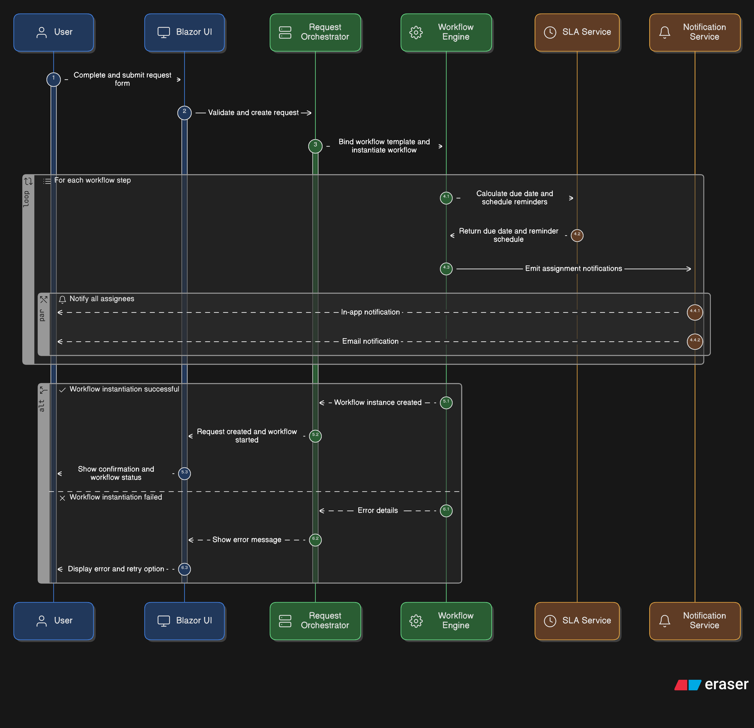

――――――――――――――――――――――――――――――――――――――――

## 11) Tech Choices & Rationale

* \*\***Blazor Server**\*\* for rich, stateful UI with minimal JS; MVC for APIs and admin.
* \*\***EF Core**\*\* for rapid iteration + migrations; read models for dashboards.
* \*\***SignalR**\*\* for real-time collaboration.
* \*\***Hangfire**\*\* for robust, retryable background jobs with dashboard.
* \*\***OpenIddict**\*\* to align with existing SSO model and role claims.
* \*\***Serilog**\*\* for structured logs and easy correlation.

――――――――――――――――――――――――――――――――――――――――

## 12) Roadmap Hooks

* Phase 2: AI-assisted triage, Teams notifications, mobile-friendly push, BPMN import/export.
* Phase 3: Cross-division workflows, external submissions (partner SSO), analytics warehouse.

――――――――――――――――――――――――――――――――――――――――

## 14) MVP Scope (Phase 0)

**\*\*Goal:\*\*** Ship a usable vertical slice for two request types with governance, audit, and basic reporting.

\*\***Included**:**

* Request types: **Consultant Request**, **ICT Support**
* Workflow engine with: Role-based + Selected-by-previous-step assignment, branching, skip rules
* Dynamic form wizard from JSON schema (+ validation, conditional fields)
* Step tasks (gating), basic dependencies, task attachments
* Comments: 2-level threads, @mentions, internal vs requester-visible
* Notifications: in-app + email templates (submission, assignment, mentions)
* SLA: due-date calc + reminders; single-step escalation
* Attachments: upload, metadata, inline viewer; soft delete
* Access control: role checks + creator/preparer flags; OIDC (OpenIddict) SSO
* Dashboards: My Requests, My Actions, SLA status; CSV export
* Audit: EntityActivityLog; basic timeline UI
* Ops: Hangfire dashboard (restricted), Serilog + health checks

**\*\*Excluded (deferred):\*\*** workflow version migration UI, multi-tenant org calendars, analytics warehouse, Teams integration.

**\*\*Definition of Done:\*\*** p95 latency targets met; zero Critical/High security findings; restore drill passed; UAT sign-off by process owners (Finance ICT).

――――――――――――――――――――――――――――――――――――――――

## 15) Phase 1 — Enterprise Hardening & Admin UX

* \*\***Workflow versioning**\*\*: `WorkflowTemplateVersion`; new vs in-flight handling; clone/deprecate actions
* \*\***Outbox pattern**\*\* for events (already added jobs) + idempotent handlers
* \*\***Optimistic concurrency**\*\*: rowversion on Request/WorkflowState/TaskItem; conflict prompts in UI
* \*\***Search & Reporting**\*\*: indexed filters, saved searches; SLA breach rate, cycle time; export API
* \*\***SLA calendars**\*\*: business hours + holidays per org unit
* \*\***Admin matrices**\*\*: Step × Role/User permission matrix; comment policy controls
* \*\***i18n/accessibility**\*\*: EN/FR resources; WCAG 2.1 AA checks

――――――――――――――――――――――――――――――――――――――――

## 16) Phase 2 — Integrations & Insights

* \*\***Teams notifications**\*\* and actionable cards (webhook/HMAC)
* \*\***Directory-backed mentions**\*\* using Staffing API (cached)
* \*\***Advanced analytics**\*\*: warehouse-friendly read models; Power BI templates
* \*\***Mobile quality**\*\*: push-friendly notification endpoints; offline-friendly comment composer
* \*\***BPMN import/export**\*\* (subset) for template bootstrap

――――――――――――――――――――――――――――――――――――――――

## 17) Security, Privacy & Compliance Checklist

* Data protection: TDE, optional column encryption for sensitive fields
* File security: AV scan hook; file-type allow list; watermarking for sensitive downloads
* Audit hardening: append-only logs with hash chaining (tamper-evident); Audit Viewer
* Secrets: Key Vault/DPAPI; periodic rotation; per-env OIDC clients
* Policy store: named authorization policies referenced by step rules (avoid raw role strings)

――――――――――――――――――――――――――――――――――――――――

## 13) Commenting & Mentions — Design Decisions

* **Thread depth**: limit to **2 levels** (comment + reply). Additional replies reference parent with quote preview.
* **Editor**: safe Markdown subset (bold/italic, code, quote, list) + paste-to-attach; strip scripts; sanitize HTML.
* **Mentions**: `@name` autocomplete from staff directory; store `Mention` rows for delivery & audit.
* **Visibility**: `Internal` comments hidden from requesters; `RequesterVisible` shown to submitter + authorized roles; per-step default.
* **Moderation**: Admins/process owners can hide/restore; original text retained in audit log.
* **Reactions**: lightweight acknowledgment (👍, ✅) reduces noise and replaces "+1" replies.
* **Performance**: server-side paging on long threads; lazy-load older replies; SignalR for live updates.
* **Access control**: only assignees/owners can comment when step is "Pending Action"; requesters can comment when waiting-for-info.

――――――――――――――――――――――――――――――――――――――――

\*\***Ready to proceed**\*\*: The architecture now includes MVP scope, phased roadmap, and enterprise hardening patterns (versioning, outbox, concurrency, scale-out, security), keeping us aligned with the BRD and standard enterprise platforms.